A MINOR PROJECT II REPORT ON

“HISAB KITAB”

Bachelor in Computer Information System

Of

BOSTON INTERNATIONAL COLLEGE



SUBMITTED BY

Subash Khatiwada

Samiksha Rana

Under the Supervision of

Nabin Kumar Shrestha,

Boston International College

Bharatpur-10, Hakim Chowk, Chitwan

[www.bostoncollege.edu.np](https://bostoncollege.edu.np/)

October 2020

**Abstract**

Hisab Kitab is a mobile application designed to improve the way how businesses make their credit and financial transaction. The digitalized system is the way how the users can record their financial statements in a way that they will be stored and retrieved in a second replacing the traditional paper system. This system also makes ease for the users to store and retrieve millions of the data and search for the specific transaction by filtering date, time, user type, etc. This system is based on the Flutter framework based on Dart programming language along with the SQLite database for smooth performance and easy to use. Using this system, after the valid user login, in the dashboard menu users can add, retrieve, update, and delete their financial transactions. And the best part of Hisab Kitab mobile application is that users can also add their bank or eSewa details and set the date of credit collection so that system can send automatic SMS including transaction details in the customer’s mobile number and WhatsApp to remind them about their billing date and amount.

**Key Words:**

Flutter, Dart, SQLite, Financial Statement, and Business and Credit transaction.

Table of Contents

1. INTRODUCTION 1

1.1 Background 1

1.2 Statement of Problem 1

1.3 Objectives 2

1.4 Hardware and Software Requirements 2

1.4.1 Hardware: 2

1.4.2 Software: 2

2. LITERATURE REVIEW 3

2.1 Case Study 3

3. METHODOLOGY 4

3.1 Tools and technologies used 4

3.1.1Flutter 4

3.1.2 SQLite 4

3.2 Architectural Representation of System 5

3.2.1 Introduction 5

3.2.2 Use Case Diagram 5

3.2.3 Flowchart 6

3.3. System Design 8

3.3.1 Introduction 8

3.3.2 ER Diagram 8

3.3.3 Database Management System 9

4. RESULT and DISCUSSION 15

5. EPILOGUE 12

5.1 Expected Output 12

5.2 Work Schedule 14

6. CONCLUSION 15

7. FUTURE ENHANCEMENTS 19

REFERENCES 20

Table of Figures

Figure 1: Hisab Kitab Use-Case Diagram 6

Figure 2: Main User Interface Design 7

Figure 3: Teacher ER Diagram 8

Figure 4: User Table 9

Figure 5: Profile Table 9

Figure 6: Transactions Table 10

Figure 7: Payment Details Table 10

Figure 8: Remainder Table 11

Figure 9: Expected Output 12

Figure 10: Work Schedule (Gantt chart) 13

# INTRODUCTION

## 1.1 Background

Hisab Kitab is a mobile application designed to improve the way to manage the business & personal ledgers on your phone. It provides the service to manage the credit of any small business or person (Khatabook, n.d.).The digitalized system is the way how the users can record their financial statements in a way that they will be stored and retrieved in a second replacing the traditional paper system. Writing credit amounts in the diary or book is no more suitable in this digital world as the users are moving toward the digitalized system. And carrying a diary everywhere is not a good choice so there is the need for a system that can hold all the data related to the amount that is to be given or taken.

Firstly, Users will have options for login or register using the phone number. The benefit of log in the user rather than email or google account is that it gives the flexibility of sending the automatic SMS or WhatsApp message using the same registered number.

After login into their statement book, they can create, update, and delete the transactions and send credit remainder to their customer. By using the Hisab Kitab app users can view their earning, their credit transactions, and the amount they have to return to their users on the specific date setting remainder to both user and their customers.

## 1.2 Statement of Problem

At present, all works are done manually with hand in the bulk of files and papers which is hard to operate and hard to maintain the report of the day-to-day transactions. A paper-based system is costly and insecure. Paper-based systems for managing information in the store or for any person is expensive because they have to report their daily activities of the sales and financial resources for both the cost of the materials and the labor power of managing them. This could mean employing additional workers and requires more salaries for some big businesses.

Besides that, the use of humans rather than software lives room for more errors such as incomplete forms, missing data, etc. Not only errors, but tasks are done by human also tends to take more time as well as more resources. The most common problem using the old paper-based method to manage any financial statements are as follows:(CreditInfo, 2018)

1. More chances for human error,
2. Hard to find past data,
3. High chance of d**ata redundancy**,
4. Expensive and hard to maintain.
5. Hard to send remainder to every customer for their credits etc.

## 1.3 Objectives

1. To provide secure transaction between users reducing the chances of error and easier to access past data.
2. To help small business owners manage their credit accounts and maintain their privacy.
3. To provide the data security & backup of the user so that they can get their data even if they lost their device.
4. To help the user get the balance, amount to be taken and amount to be paid at a glance setting the remainder.

## 1.4 Hardware and Software Requirements

In this system, the hardware and software that are going to be used are very low and can probably run on any mobile phone either in Android and iOS with limited specifications.

### 1.4.1 Hardware:

* RAM: Recommended 4 GB or above
* Processor: Intel i3 or above.
* Hard-disk Storage: 2 GB or more

### 1.4.2 Software:

* Operating System: Windows 7 or above
* Front End tool: Flutter
* Back End tool: SQLite

# LITERATURE REVIEW

There was a lot of research and project works done previously on the financial statement applications like Hisab Kitab.Some of those studies are described below:

## Case Study

The main inspiration for this Hisab Kitab application is an Indian application named Khata Book with millions of downloads on the Play Store and AppStore. Doing the research of Hisab Kitab mobile application on the internet, we have found a different way of managing the interaction between business and customers digitally. Similarly, different scholars connect the issue and trends to be follow to move our business in digitalized world. Though there are different digitalized systems of financial statement applications on the market today still there are lots of businesses or persons especially in Nepal who are still using traditional file-keeping methods. In the existing traditional system, business owners or individuals usually use physical books or diaries to record the credit information or record the amount that they have to pay or they will get, which is very old and complicated.

While doing the research on this topic we have found that users are not using that kind of system because of a lack of trust in those foreign products. They hesitate to give their financial details to those non-trusted organizations or companies. Many users are also not using the system due to their complex user interface. So, we are mostly focusing on the simplest user interface for the user to use and they can forget their traditional fie-keeping system.

# METHODOLOGY

## 3.1 Tools and technologies used

This project will build on the Flutter framework based on Dart programming language for the frontend or the UI of the system and for the backend we are going to use the ‘SQLite’ database. The tools and technologies used for building this project are Android Studio or Visual Studio Code for writing the flutter programs and using the virtual devices to run and debug our proposed system in a different interface having different built-in features.

### 3.1.1Flutter

Flutter is a free and open-source mobile UI framework created by Google and released in May 2017. In a few words, it allows us to create a native mobile application with only one codebase. This means that you can use one programming language and one codebase to create two different apps (for both iOS and Android).

Flutter uses the programming language called Dart. It consists of two important parts as, Software Development Kit (SDK) and a Framework (UI library based on widgets). It also has good documentation which helps in any problem and it is easy to learn.(Thomas, 2019)

### 3.1.2 SQLite

SQLite is a C-language library that implements a small, fast, self-contained, high-reliability, full-featured, SQL database engine. SQLite is the most used database engine in the world. SQLite is built into all mobile phones and most computers and comes bundled inside countless other applications that people use every day.

The SQLite file format is stable, cross-platform, and backward compatible. SQLite database files are commonly used as containers to transfer rich content between systems and as a long-term archival format for data. There are over 1 trillion SQLite databases in active use which makes it easy to find solutions in large communities. (SQLite, n.d.)

### 3.1.3 MySQL

MySQL is an open-source relational database management system. Its name is a combination of "My", the name of co-founder Michael Widenius's daughter, and "SQL", the abbreviation for Structured Query Language.The data in a MySQL database are stored in tables. A table is a collection of related data, and it consists of columns and rows for online data storage. (M Widenius, 2002)

## 3.2 Architectural Representation of System

### 3.2.1 Introduction

Today’s wide-scale software systems are among the most complex structures ever built by humans, containing lines of code, database tables, and components, all running computers. This makes some big challenges to software development teams and if these challenges aren’t handled early, systems are delivered late.

The system architecture is the conceptual model that defines the structure, behavior, and more views of a system through architectural design. This software design document is to providing insight into the structure and design of each component. In short, this document is meant to equip the reader with a solid understanding of the inner work of the Hisab Kitab mobile application. While the problem definition document is written for a more general audience, this document is intended for individuals directly involved in the development of the Hisab Kitab app.

### 3.2.2 Use Case Diagram

A use case is a sequence of transactions in a system whose task is to yield a measurable value to an individual actor of the system.

A Use Case model is described in UML (Unified Modeling Language) as one or more Use Case Diagrams (UCDs). (Shrestha, 2019)

A UCD has 4 major elements:

* The **system** described
* The **actors** that the system interacts with
* The **use-cases**, or services, that the system knows how to perform
* The **relationships** between the above elements

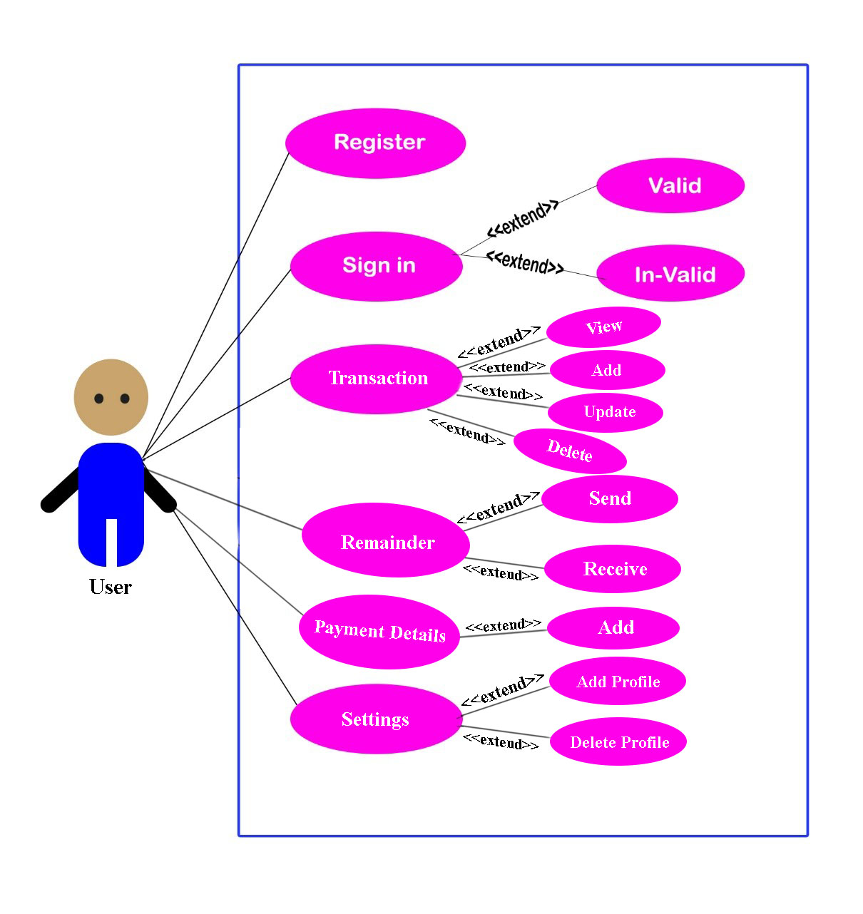

Figure 1:Hisab Kitab Use-Case Diagram

### 3.2.3 Flowchart

A flowchart is a type of diagram that represents a workflow or process. The use of flowchart makes understanding as well as creating software easily. For our software, we have created a flowing flowchart. Since our program is a menu-based program, we have some pre-defined choices as shown below. As we have mentioned below in our flowchart, we will have the main 3 menus in the Home tab. Thesemenus will display only aftersuccessful login.(Poudel, 2019)

Start

NO

If login=

Valid

Login Failed

Bill

YES

Display Choices

YES

If choice=

Dashboard

Display, Add, Update and Delete transactions

Bill

NO

If choice=

Payment

YES

Add payment details, view & send payment remainder

Bill

NO

YES

Add, Delete & Update profile

If choice=

Setting

NO

Return

Bill

Figure 2: Main User Interface Design

## 3.3. System Design

### 3.3.1 Introduction

System design is the process of defining the architecture, modules, interfaces, and data for a system to satisfy specified requirements. System design could be seen as the application of systems theory to product development. There is some overlap with the disciplines of systems analysis, systems architecture, and systems engineering.(Shrestha, 2019)

### 3.3.2 ER Diagram

Entity Relationship Diagram is a data model utilizing several notations to depict data in terms of the entities and relationships described by that data. It has an Entity, Relationship, and Attributes.(Shrestha, 2019)

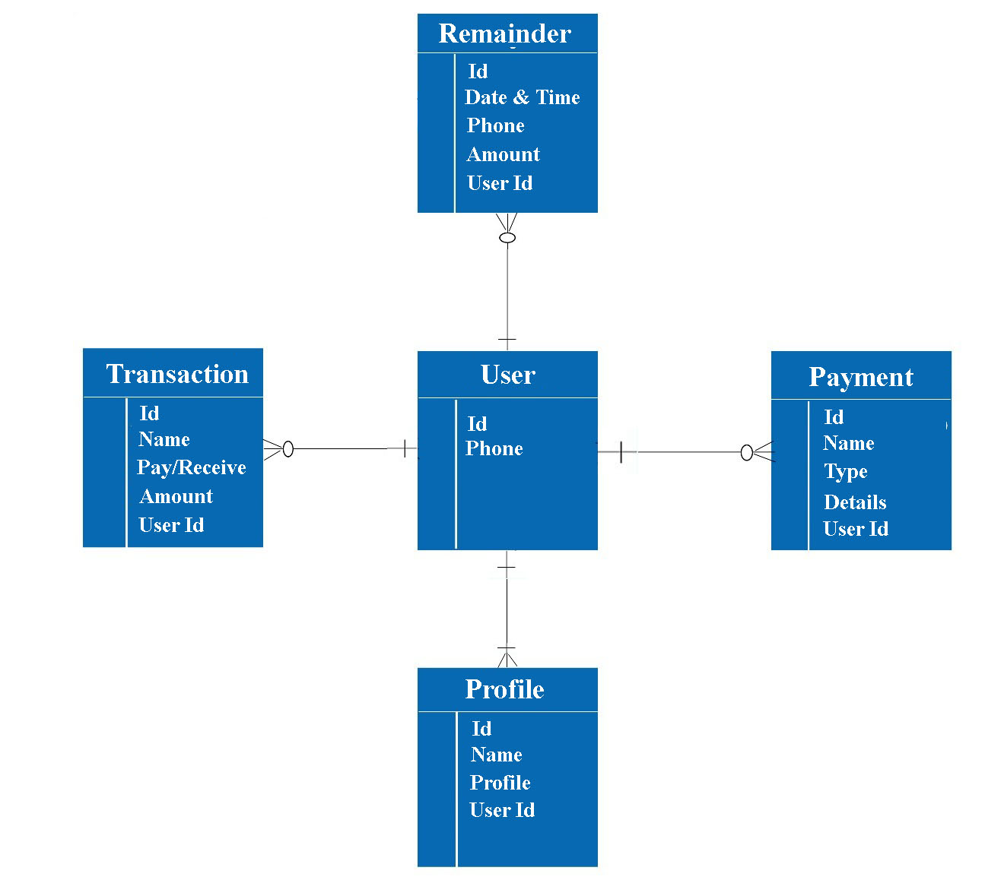

Figure 3: Teacher ER Diagram

### 3.3.3 Database Management System

The database management system (DBMS) is the software that interacts with end-users, applications, and the database itself to capture and analyze the data. The DBMS software additionally encompasses the core facilities provided to administer the database.

In order to support all the information followed in this software, this software will include 2 main tables. The first table will consist of login information and the second consists of the registration information of the user.(Poudel, 2019)

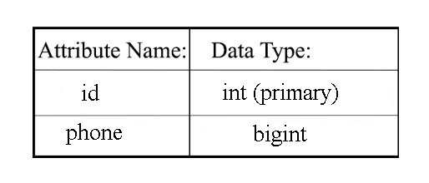

Figure 4: User Table

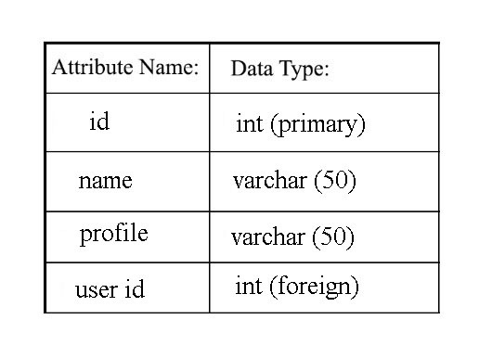

Figure 5: Profile Table

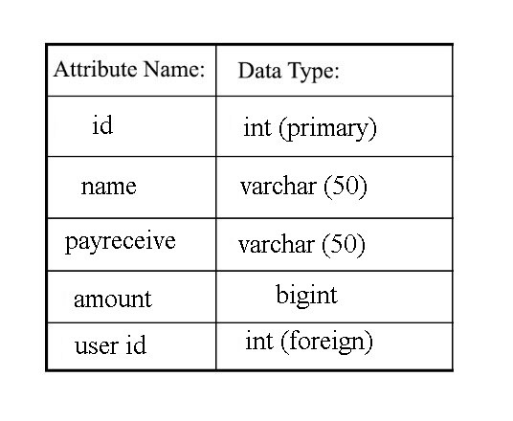

Figure 6: Transactions Table

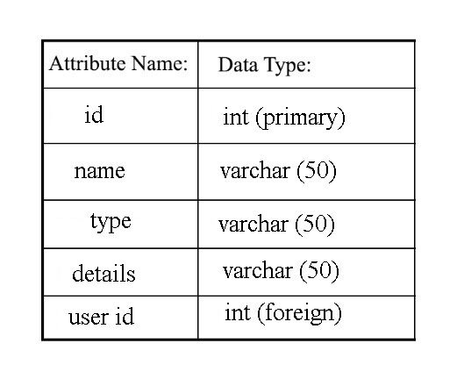

Figure 7: Payment Details Table

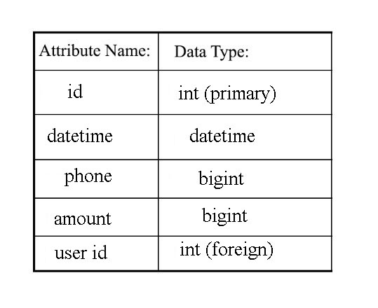

Figure 8: Remainder Table

# EPILOGUE

## Output

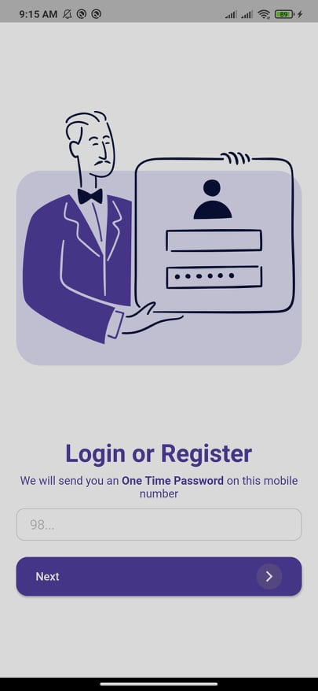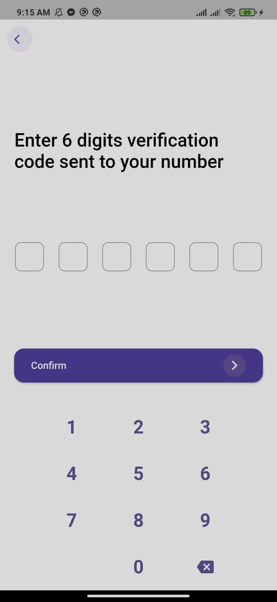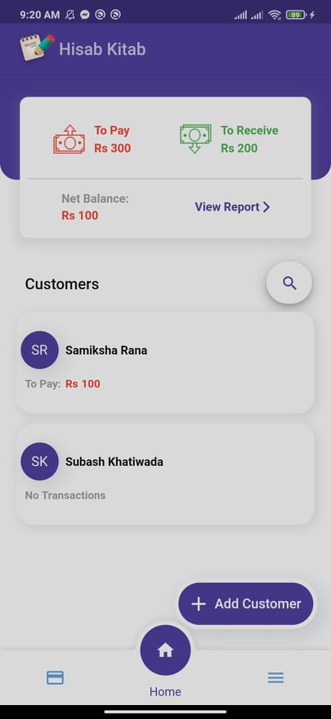

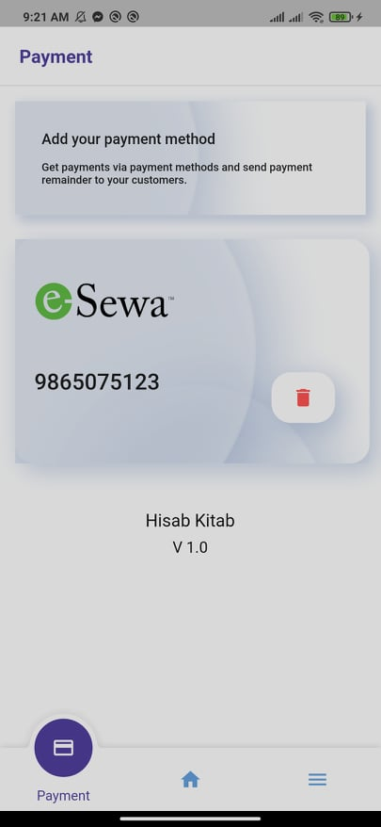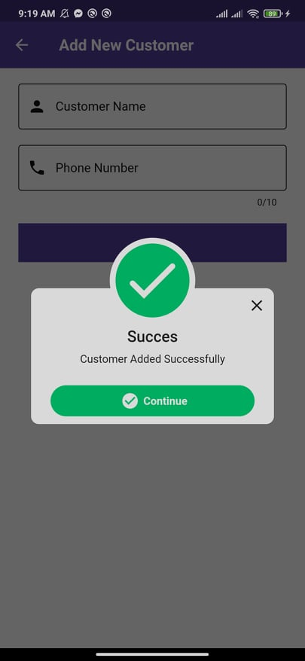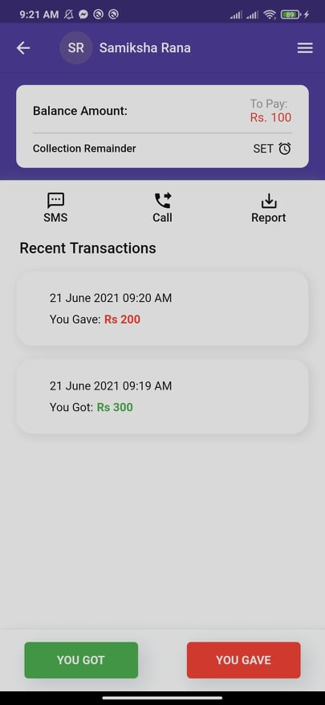

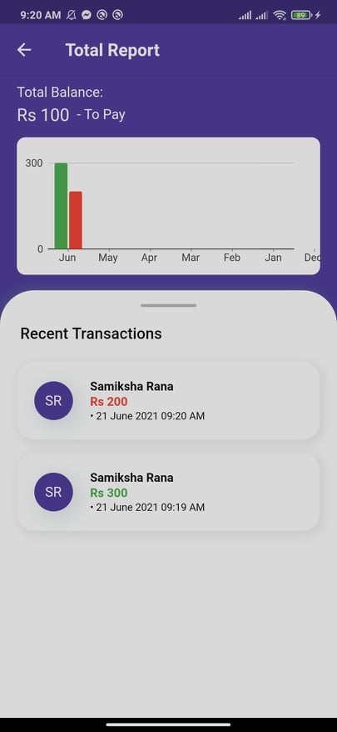

Figure 9: Output

## Work Schedule

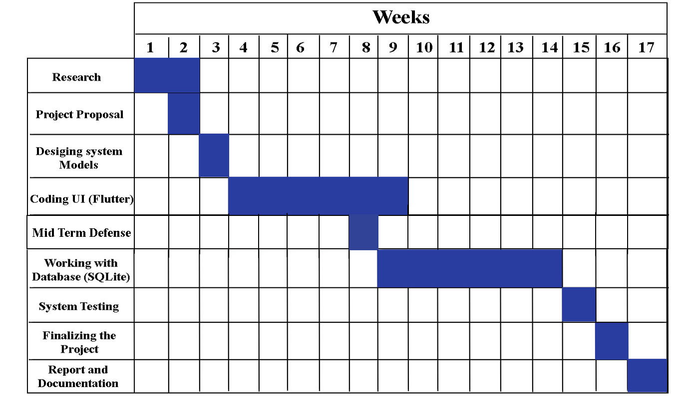

Figure 10: Work Schedule (Gantt chart)

# RESULT and DISCUSSION

Hisab Kitab is a mobile application designed to improve the way how businesses make their credit and financial transaction. The project which we started before has been done. As we said this project is built on the ‘Flutter’ framework based on Dart Programming language for frontend or UI of the system and ‘SQLite’ database for the backend. The tools and technologies used for this project is Visual-Studio code for writing the flutter programs and using the virtual devices to run and debug our proposed system in different interfaces having different built-in features. There is also the multiple profile feature in this application which is actually in the process of future updates .

Firstly, Users will have options for login or register using the phone number. The benefit of log in the user rather than email or google account is that it gives the flexibility of sending the automatic SMS or WhatsApp message using the same registered number.By using the Hisab Kitab app users can view their earning, their credit transactions, and the amount they have to return to their users on the specific date setting remainder to both user and their customers.

The following are the few screenshots of the front-end of Hisab-kitab application based on flutter framework.

  

  



* The first picture represent the log-in method where the user can log in if he/she already have their ccount on this apps. If they don’t they can register the,self and can create an account. This apps help them to keep every records of their financial activities.
* The second picture represents opt verification. OTP Verification verifies Email Address/Mobile Number of users by sending OTP verification code during registration and login. It removes the possibility of a user registering with fake Email Address/Mobile Number. The plug in also checks if Email Address/Mobile Number of a user already exists.
* The third picture represents the home page of this application . The homepage is the area that people notice at the first glance and decide their basic judgments about the application. The application homepage design is the door to a successful product, and a good start is half the battle.
* The fourth picture represents the payment method. It helps us to send payment remainder to the customers. For eg. Dear customer, you have Rs. 5000 payable amount. Please deposit it in our esewa account 9812345678. Thankyou !. This types of notification can be send to the customer.
* In the fifth picture, it shows that we can add the new customer with their resgistered number.
* And the sixth picture represents the single customer’s / user’s profile. It shows that how much money we need to pay or receive from the customer. Here we can add more number of customers records. It shows the balance records, and all financial records of users. In this , the records of receiving and paying amount of user are stored.
* The last seventh picture represents the total report page of a customer’s account transactions. It shows all of the records activities of a customer.
* And all of this records are collected and stored in the database and can retrieve when needed in future.

The functionality of the hisab-kitab application are described above.

## 5.1. WORK TO BE DONE

* The front-end and the back-end SQLite database is completed.
* The multiple profile features part is running for the future update and not completed yet.

# CONCLUSION

To Conclude, Hisab Kitab mobile application is basically a credit management system which can access all the databases and picks up different function through the user interaction in the system. Users can view, add, update, and delete the financial report or transactions and mainly send the SMS reminder to the user for remaining credit transactions in their due date. Lastly, it is a very easy implementation environment and generate report flexibly and can change the way how business and individual manages their ledgers on their fingertip.

# 7. FUTURE ENHANCEMENTS

This system has a very vast scope in the future. The project can be implemented in the online store and can be updated in the near future as and when the requirement for the same arises, as it is very flexible in terms of expansion. With the proposed software of database space, the client is now able to manage and hence run the entire work in a much better, accurate, and error-free manner. The following are the future scope for the project:

* Can add expenses tracker and calculate profit and loss
* Can add different tools like tax calculator, billing system and more
* Will also work on data security, data integration and building more user friendly UI’s.

# REFERENCES

Chaudhary, U. (2019). *Sample Proposal Defence.* Chitwan: Utsav Chaudhary.

CreditInfo. (2018, February 10). *synopsis of khatabook clone.* Retrieved from myreadingroom.co.in: http://www.myreadingroom.co.in/notes-and-studymaterial/65-dbms/461-problems-with-file-system.html

Khatabook. (n.d.). *Khatabook*. Retrieved from Home page: https://khatabook.com/

M Widenius, D. A. (2002). *MySQL Reference Manual: Documentation from the Source.* Retrieved from https://books.google.com/books?hl=en&lr=&id=9c-pkLaNmqoC&oi=fnd&pg=PR5&dq=mysql+scholar+articles&ots=G2mzcVT0q6&sig=1K6Ca8h2SmL9ahyWs3KKMoz7-_A

Poudel, S. (2019). *Hotel Management System.* Bharatpur: Raju Dhakal.

Shrestha, N. (2019, 8 9). System analysis and design. Bharatpur, Hakim chock, Nepal.

SQLite. (n.d.). *What is SQLite*. Retrieved from SQLite: https://www.sqlite.org/index.html

Thomas, G. (2019, 12 12). *What is Flutter and Why You Should Learn it in 2020*. Retrieved from FreeCodeCamp: https://www.freecodecamp.org/news/what-is-flutter-and-why-you-should-learn-it-in-2020/